Android Repackaging Attack Lab

Task 1: Obtain an Android App (APK file) and Install It

We download the RepackagingLab.apk and install it to the android VM. Before that we find out the I.P of the VM and connect it to the network that is connected to the Ubuntu VM.

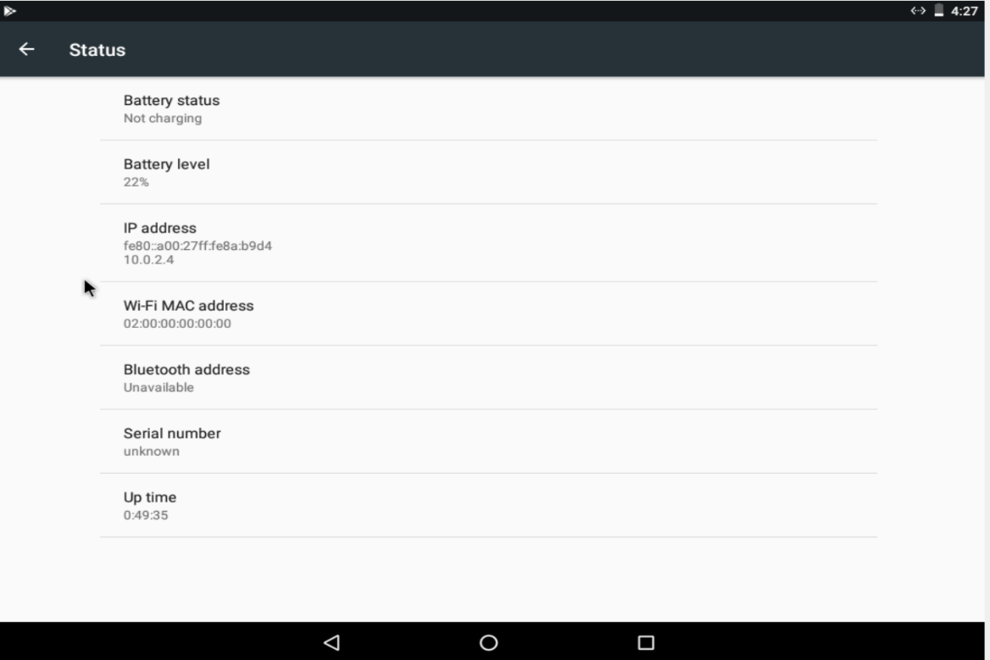

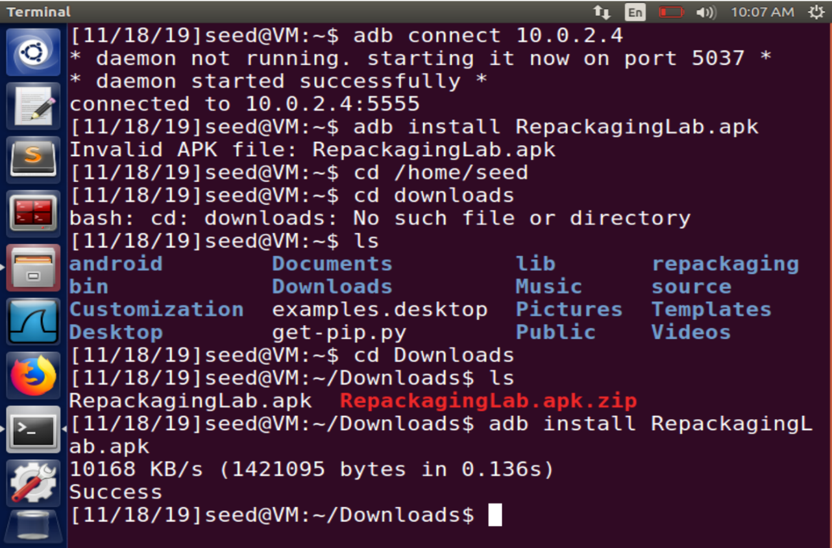

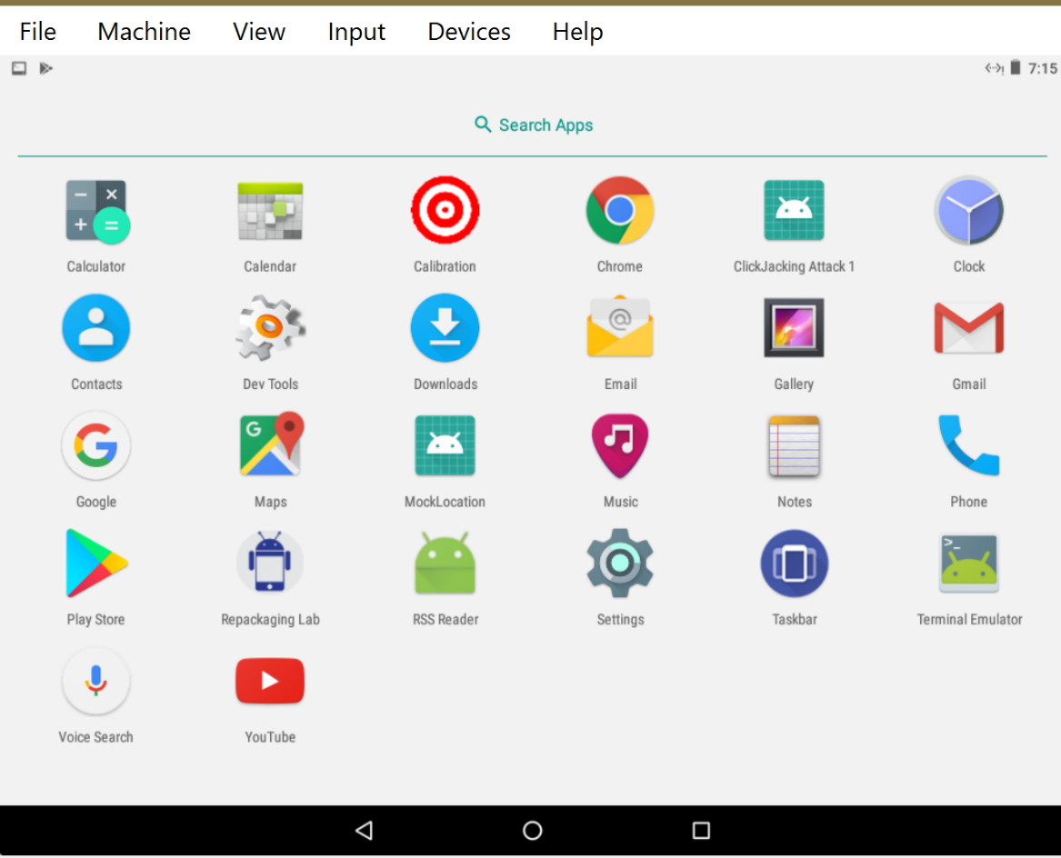

Task 2: Disassemble Android App

To inject the malicious we need to disassemble the app. For this we use apktool and disassemble it to inset our smali code and modify the AndroidManifest XML file. Apk file is basically a zip file which the apktool unzips and decodes its

content.

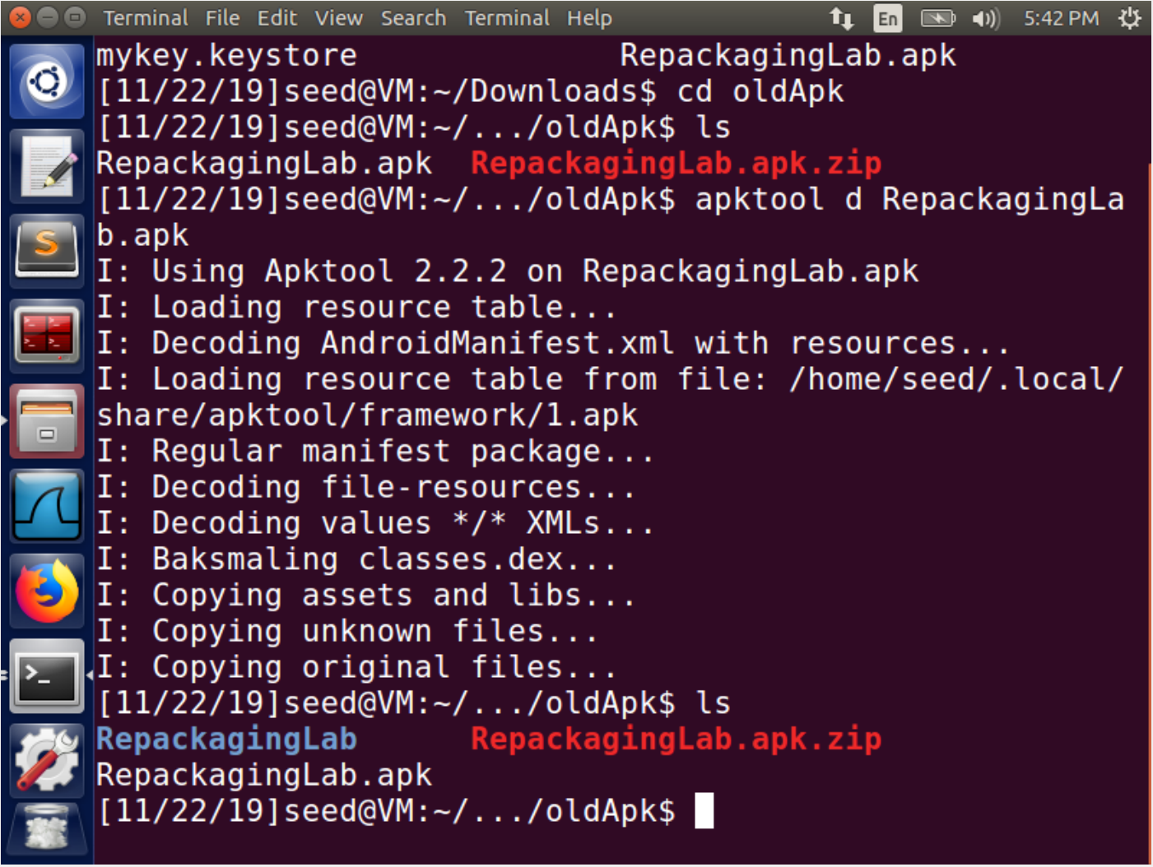

Task 3: Inject Malicious Code

We now insert our malicious code that deletes all contacts of the Android OS. To trigger the code we set up a broadcast receiver in the app, that triggers the malicious code when the broadcast message is received. The broadcast message in this case is the TIME_SET event. We insert this code in the AndroidManifest XML file.

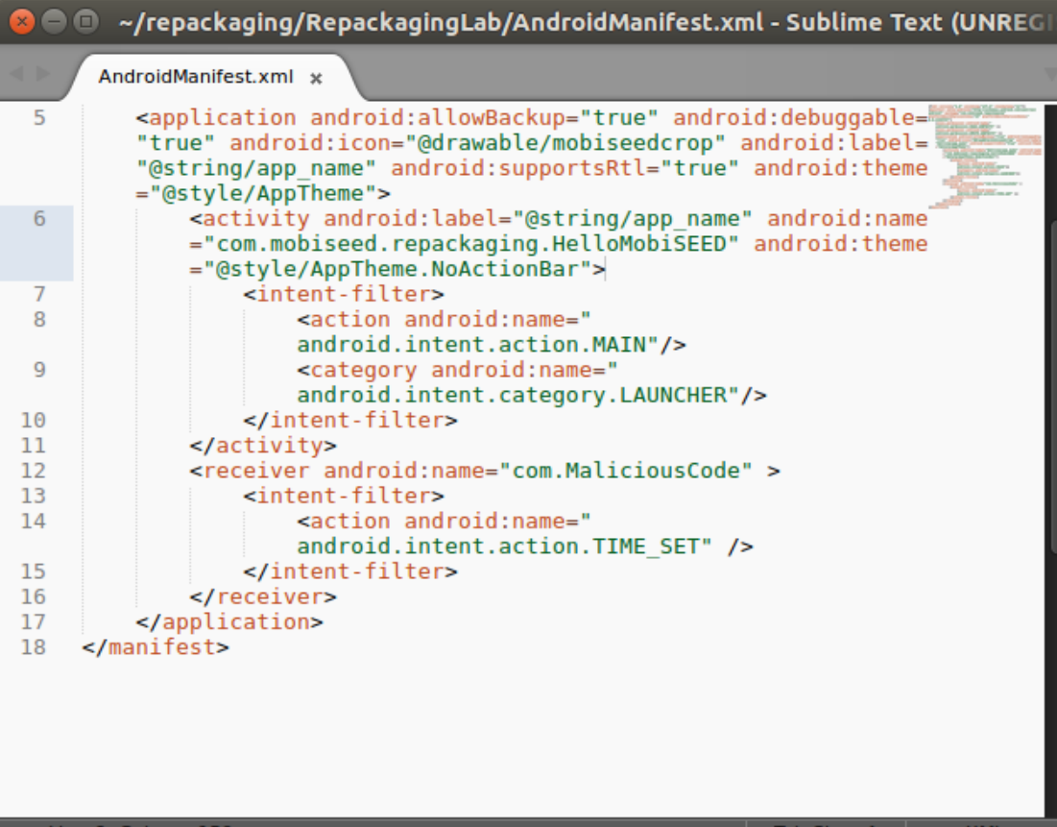

The event hence triggers the code in the com folder which is our MaliciousCode smali file.

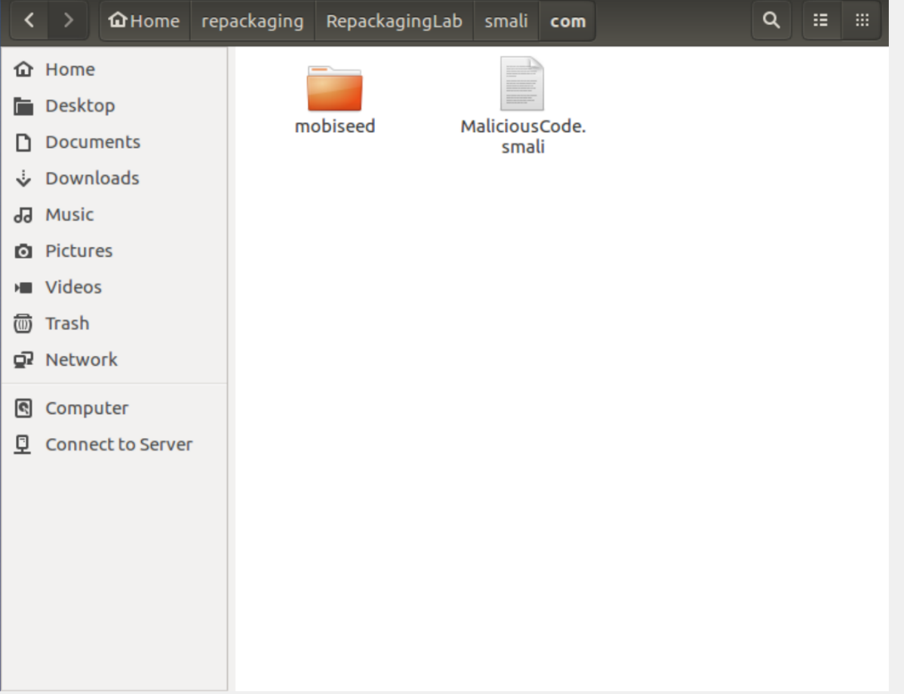

Task 4: Repack Android App with Malicious Code

Step 1:

We repack the app with the inserted malicious code. This app is stored in the dist directory

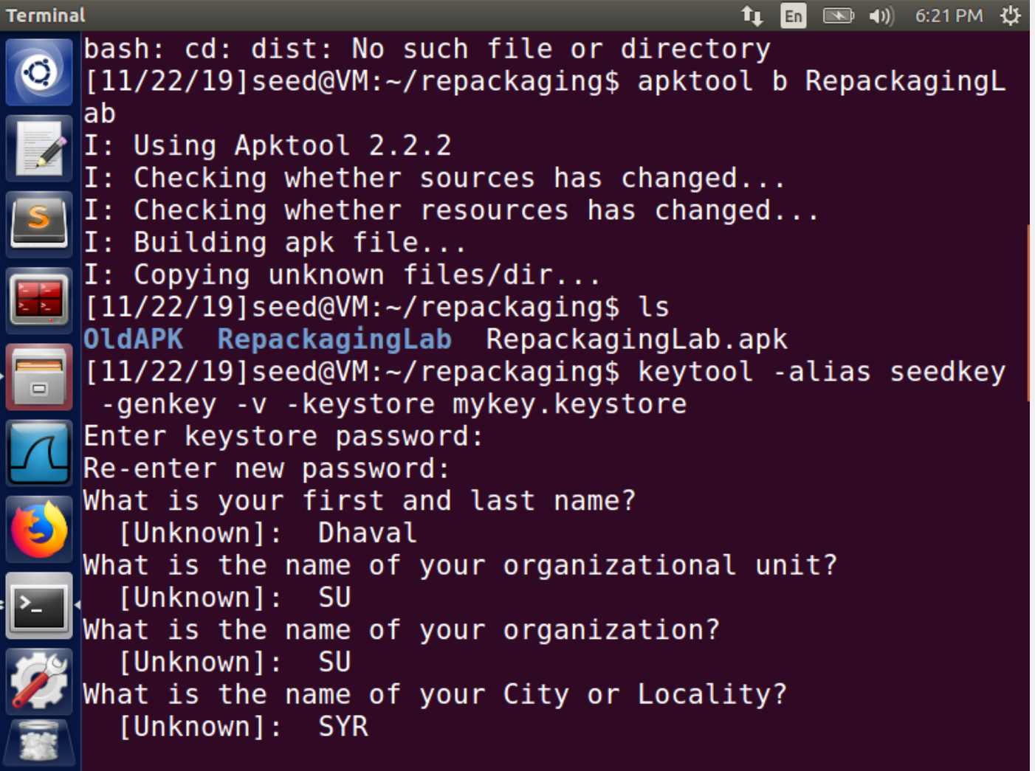

Step 2: Sign the APK file:

Every apk is signed by the developer. If not signed by the developer or a

certificate authority, the apk cannot be installed on the mobile device. Therefore we

generate a key and using a jarsigner we assign this key to our apk file.

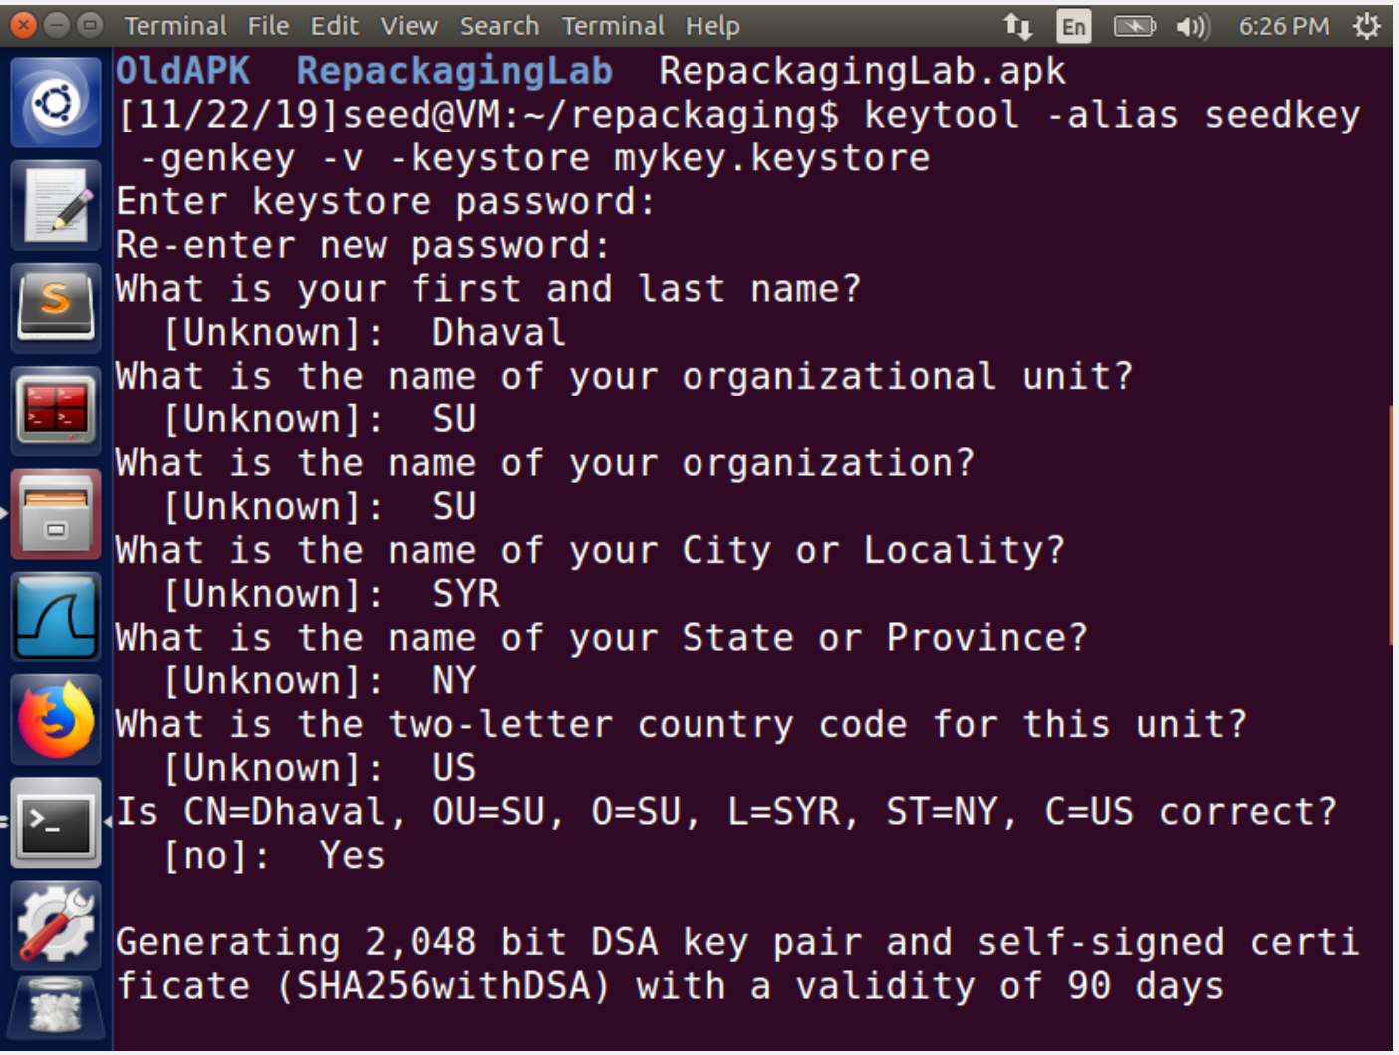

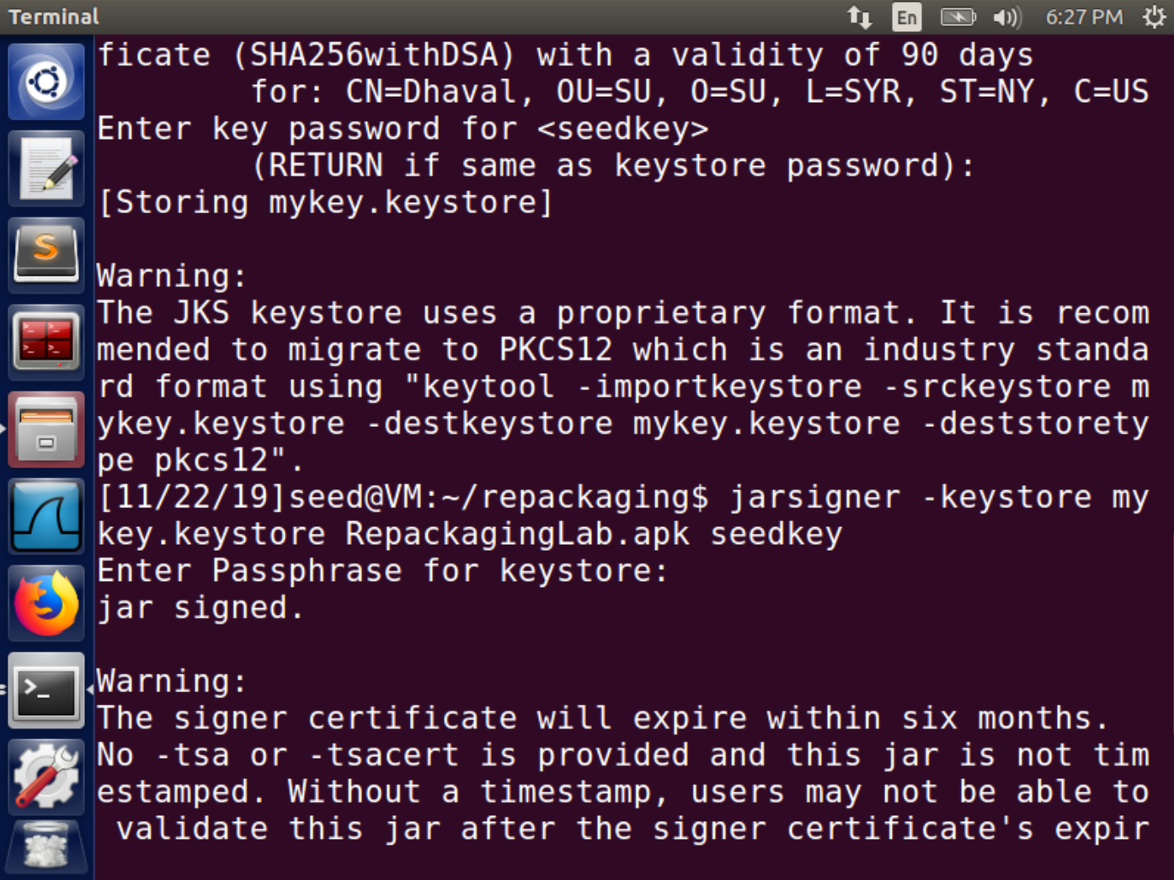

Task 5: Install the Repackaged App and Trigger the Malicious Code

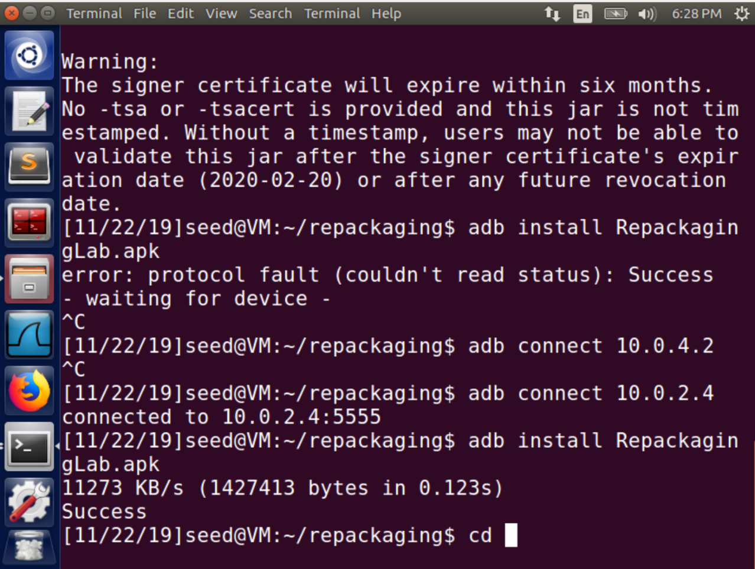



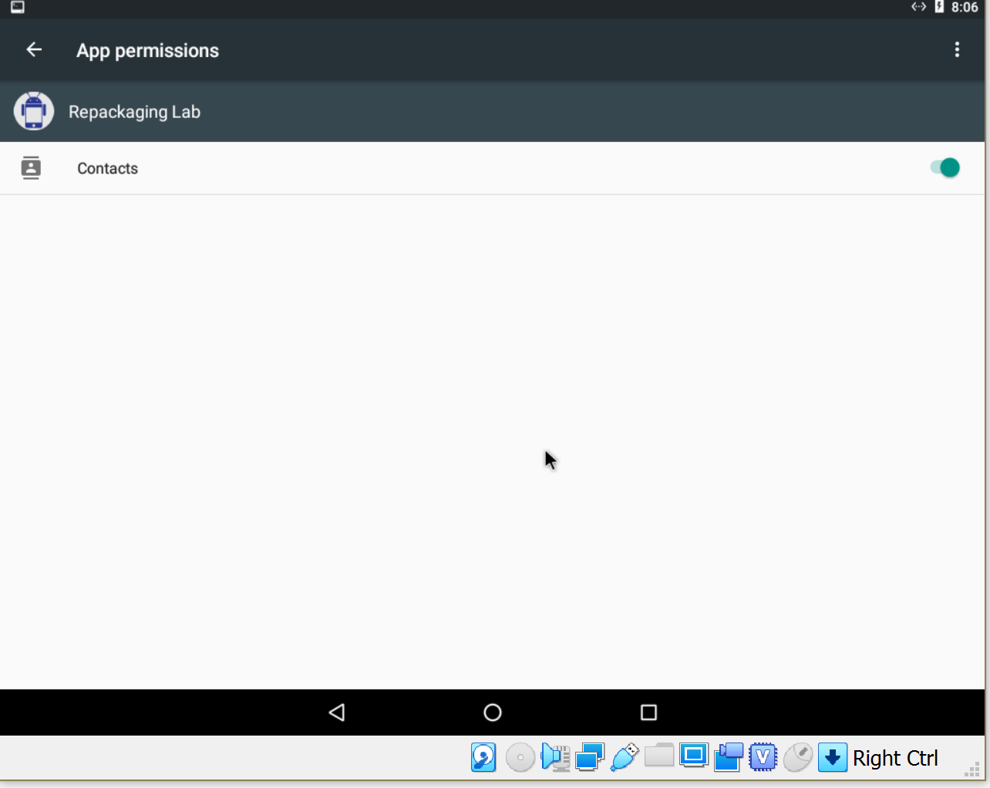

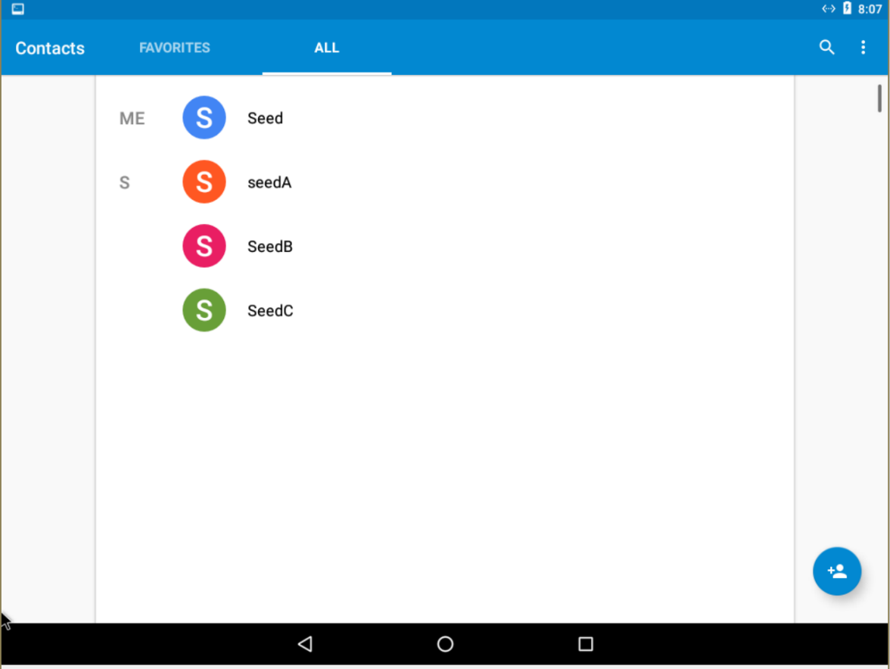

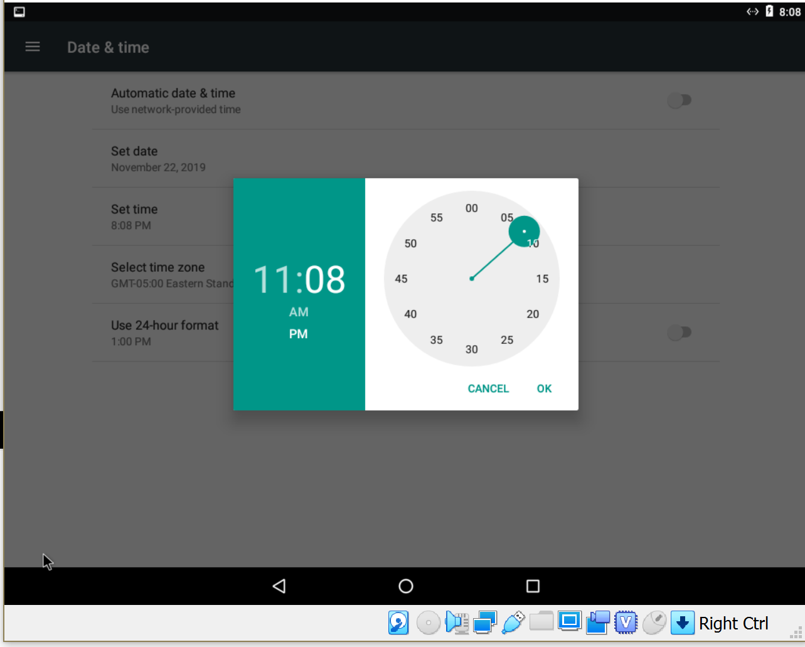

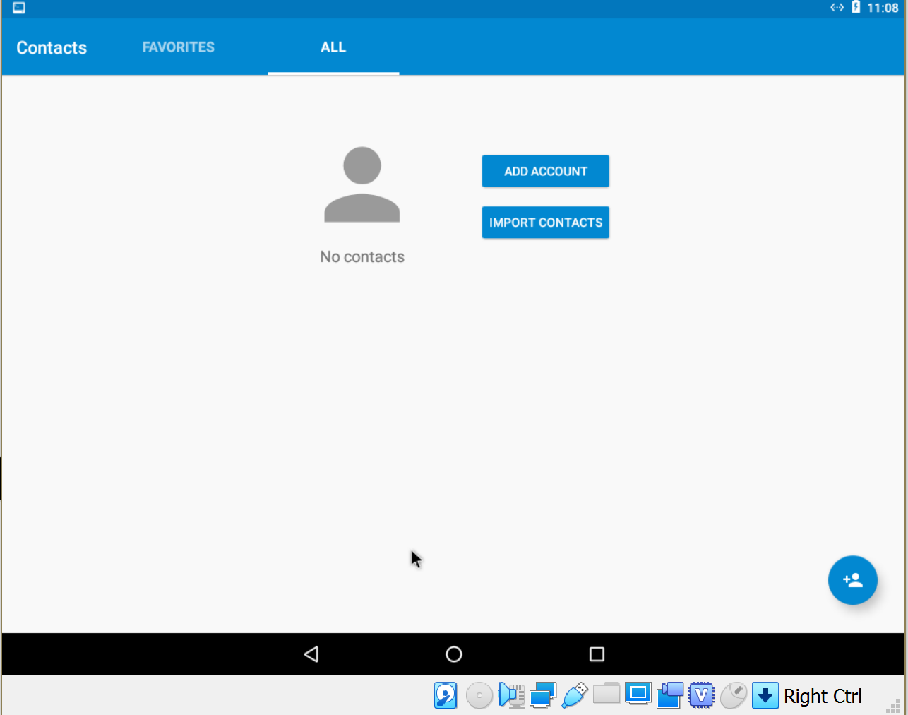

**Observations:** As it can be observed from the first screenshot we have connected the VM

to our attack machine and install the repacked apk onto the android VM. In the second

screenshot we can see that there are two contacts in the contact directory. As our malicious

application is going to delete all the contacts it needs permission to access the contacts. In

the third screenshot it can be observed that we have given permission to access the contacts.

In real world scenario, the market place asks for the permission of the user before installing

the application and when user grants it, the market place tell the system that user has

granted access permission to the following services or applications. We start the app and

then go to date and time settings and set the time as evident from screenshot 4. We can

observe in the screenshot 5 that all the contacts are deleted.

When we run the android application and operate anything on the device, if there is any

activity in time-date or reboot etc. on the android by the user, it will send a broadcast

receiver to all the applications. As in our application, in our manifest file, if we receive a

broadcast regarding the time setting then it will invoke our malicious code and thus our

malicious code will be executed.

Task 6: Using Repackaging Attack to Track Victim’s Location

Step 1. Setting up mock locations.

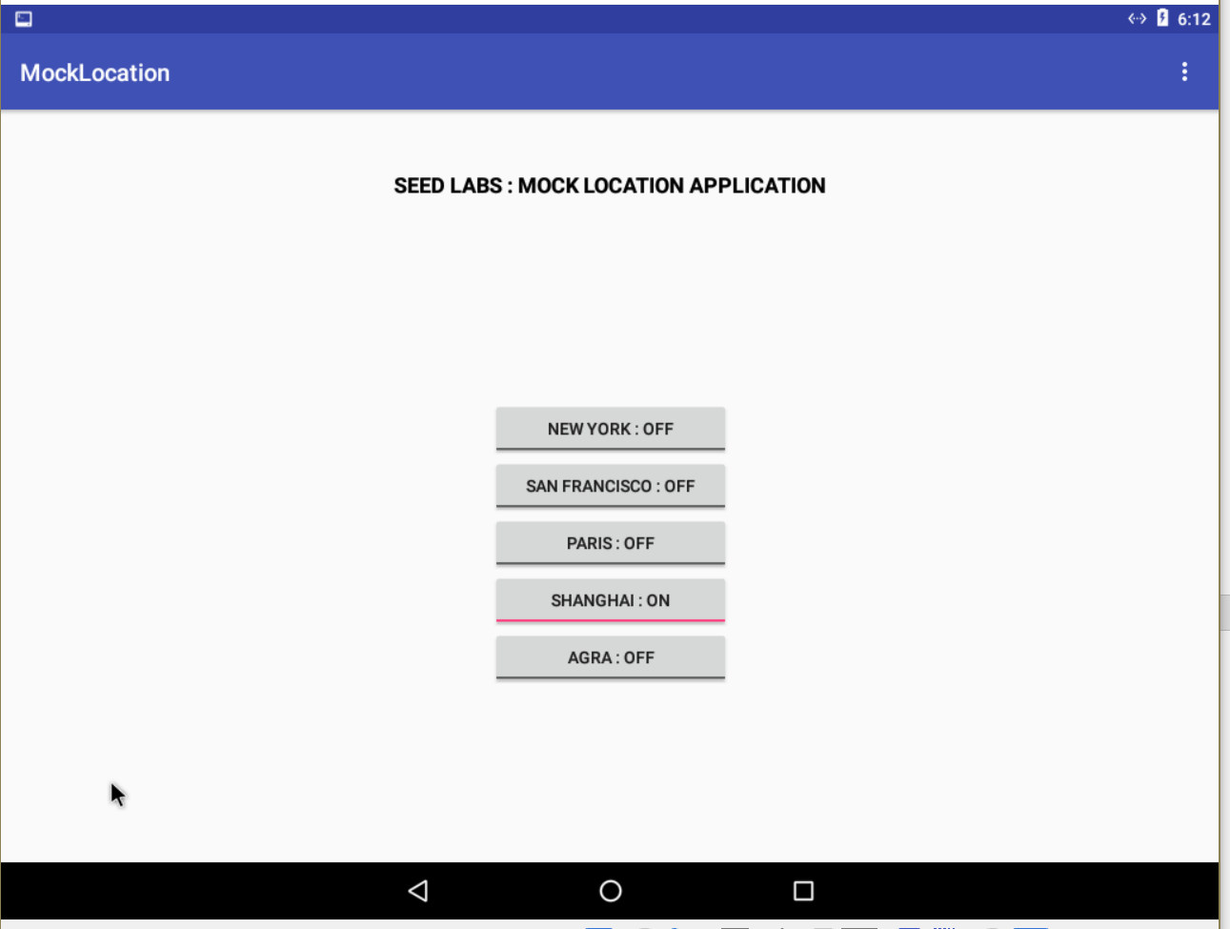

Since, we are running a VM it is not possible to use the GPS hardware. The OS allows us to mock a location using an application, which will be set as our current location.

Step 2: Configuring DNS.

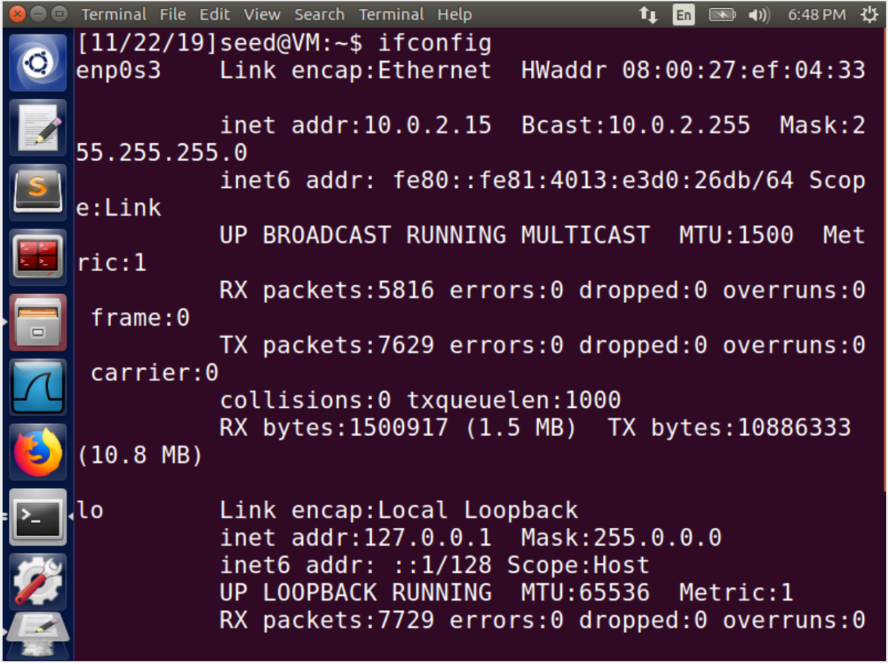

The malicious code that we will insert in the apk will broadcast the current location. This location has to be viewed in the Ubuntu VM. Using adb we pull out the hosts file from the android VM and enter our

record wherein we input the ip address of the ubuntu VM against the url that we have for

our attack. This is not a real url, however, when the malicious code is invoked the android

system will look for this url to send the data and thus will look into hosts file and will send

the data to the ip address of the ubuntu VM.

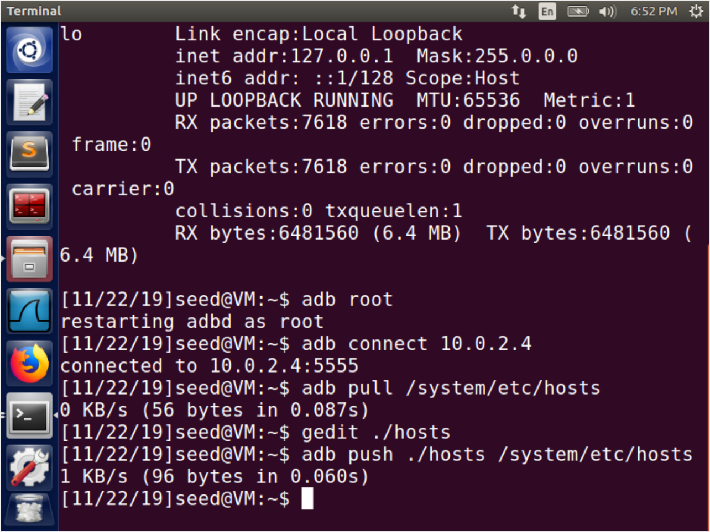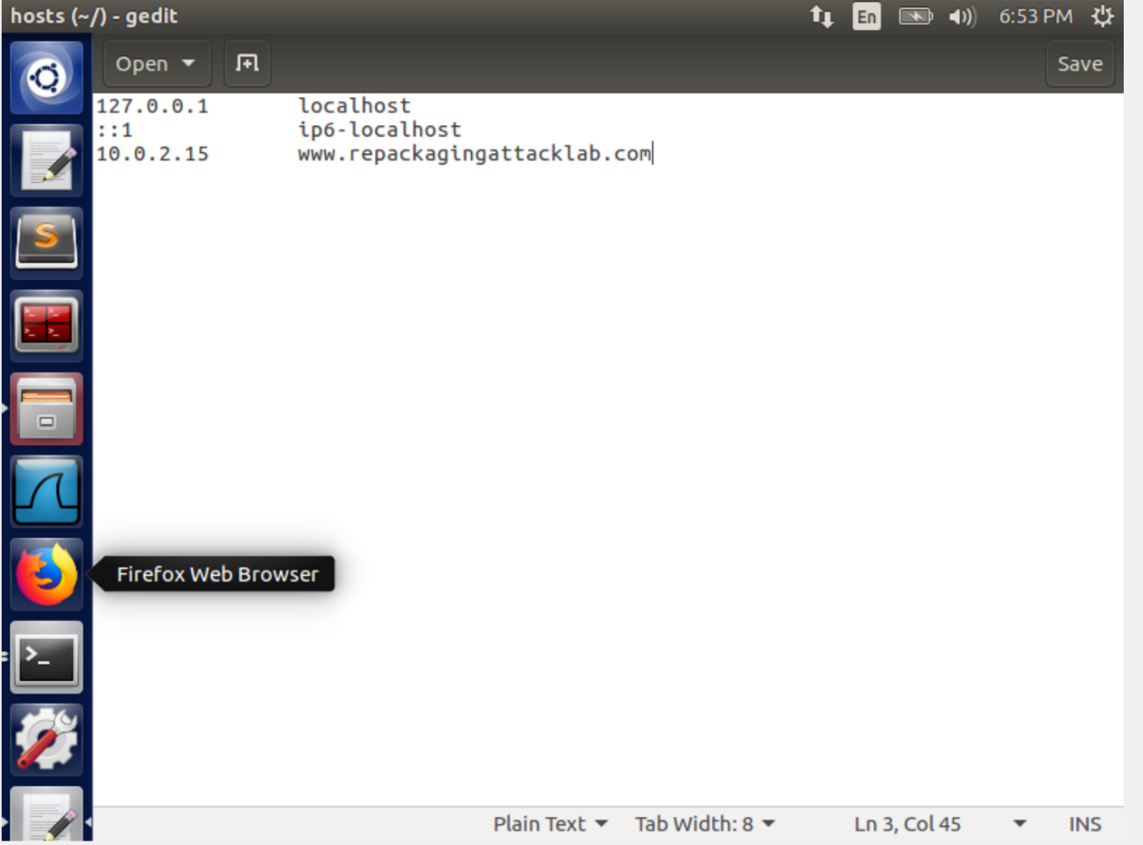

Step 3: Repackaging and installing the victim app.

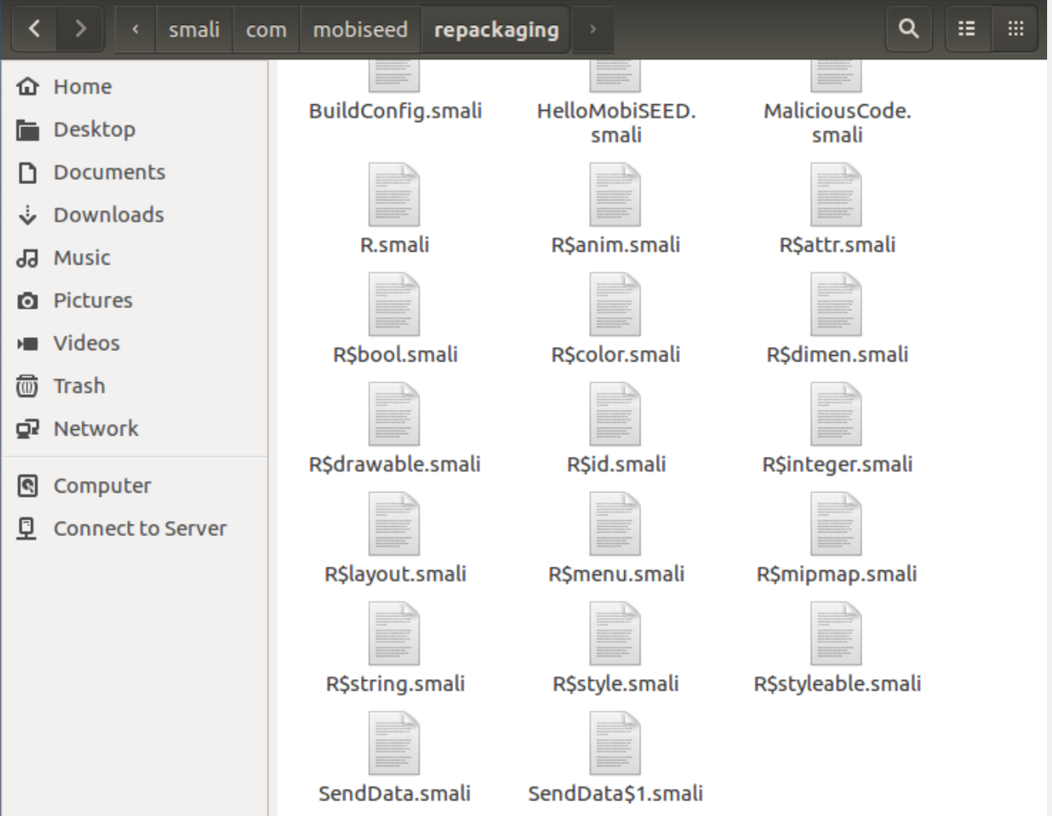

Explanation:

We insert our code that will send the location at the specified DNS that has our Ubuntu IP. Then we make the necessary changes like we did in the previous task that specifies that this app needs location permissions and will trigger a code when a broadcast event of TIME_SET is received.

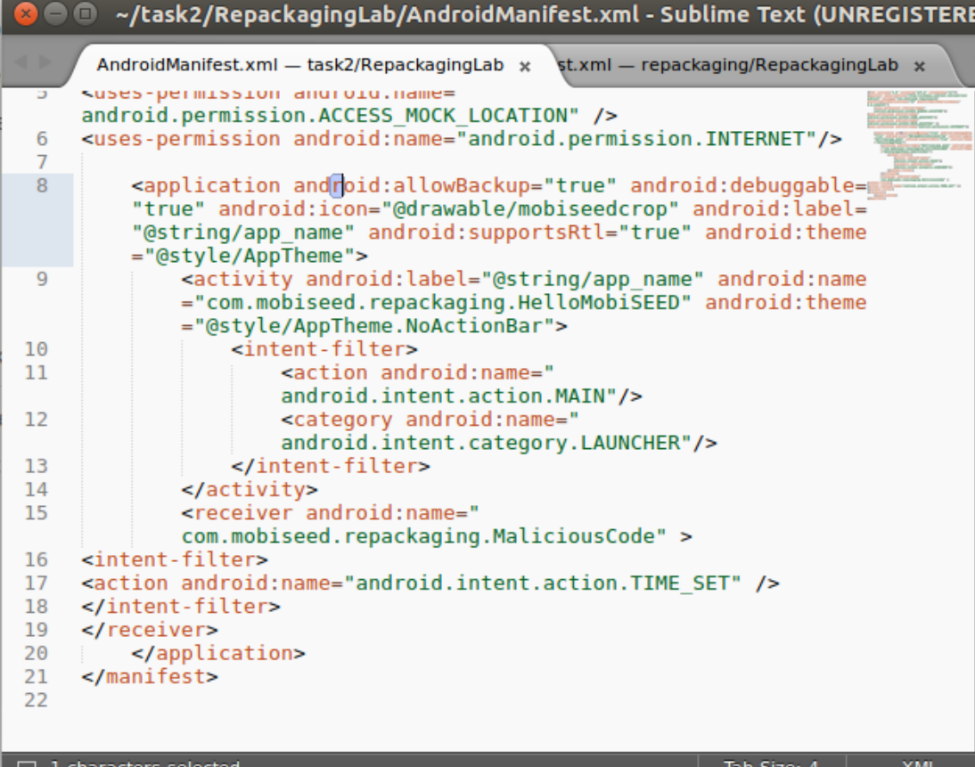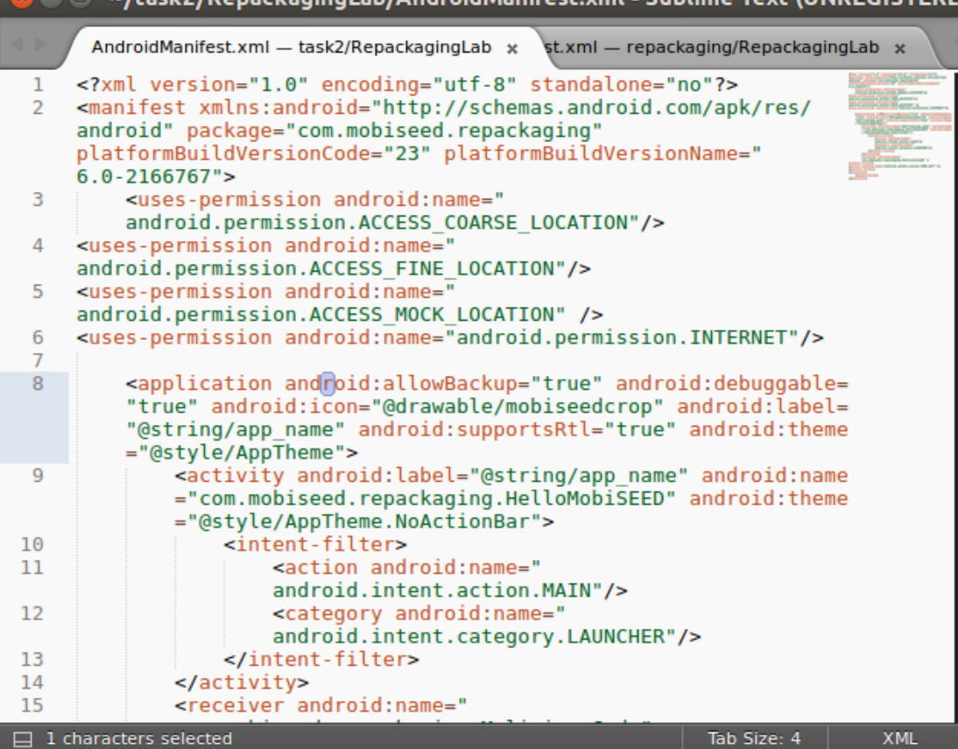

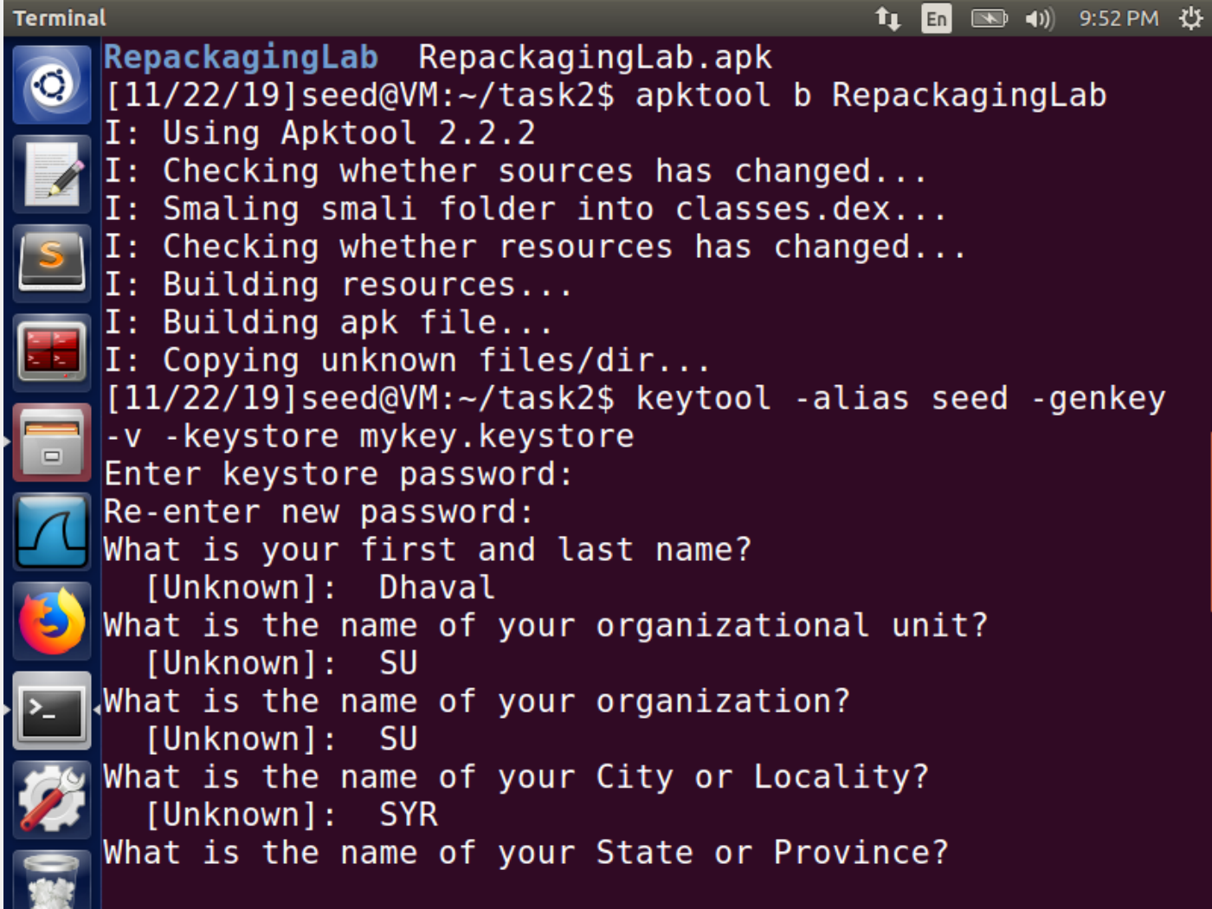

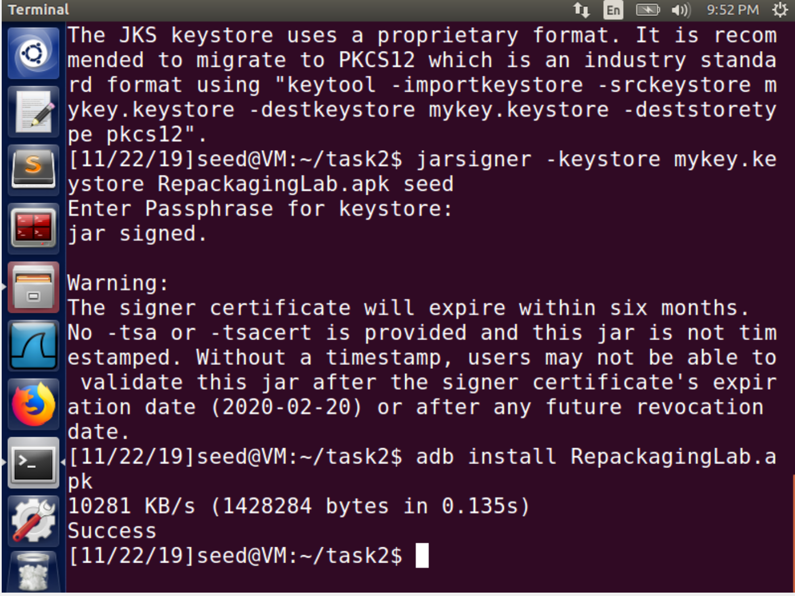

Step 4: Enabling the permission on the Android VM

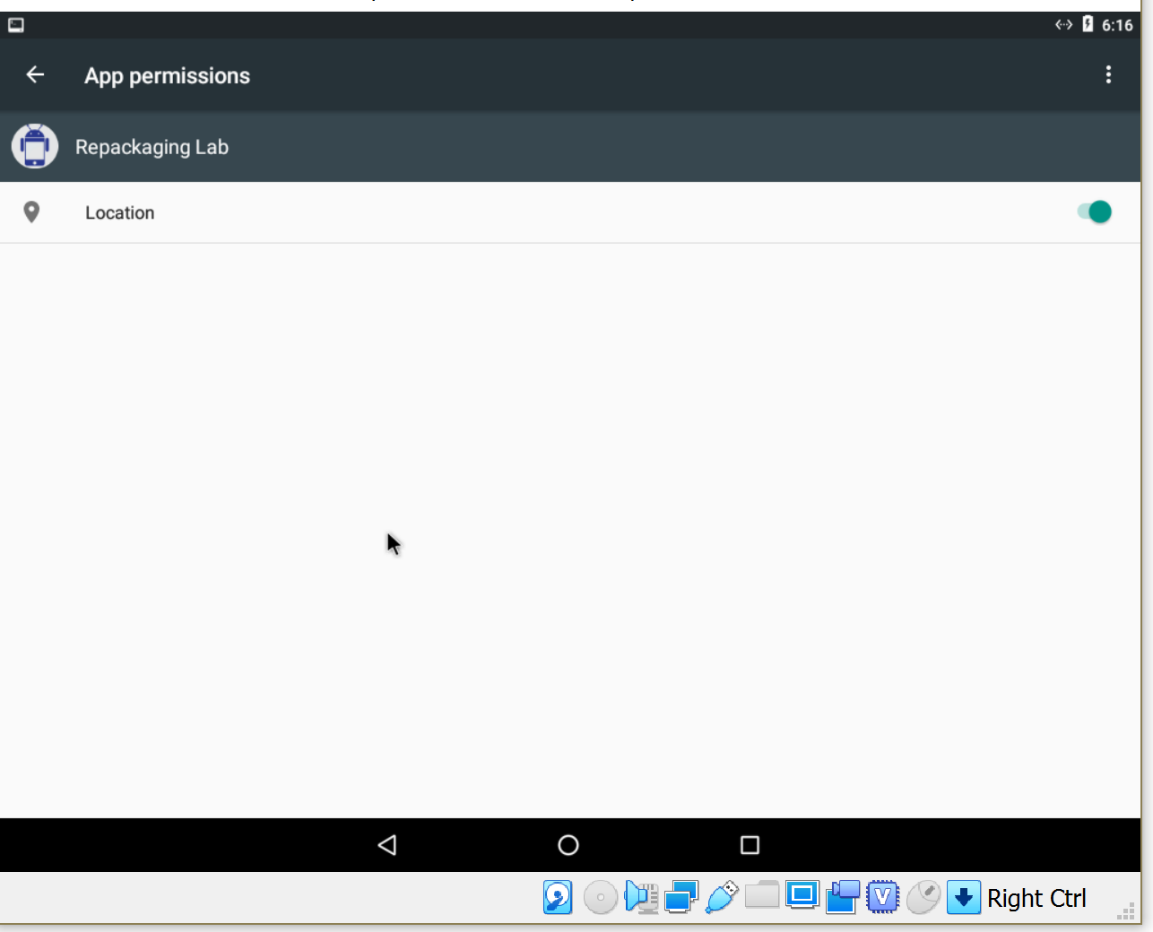

We install the application and permit it to use our mock location.

Step 5: Triggering the attacking code

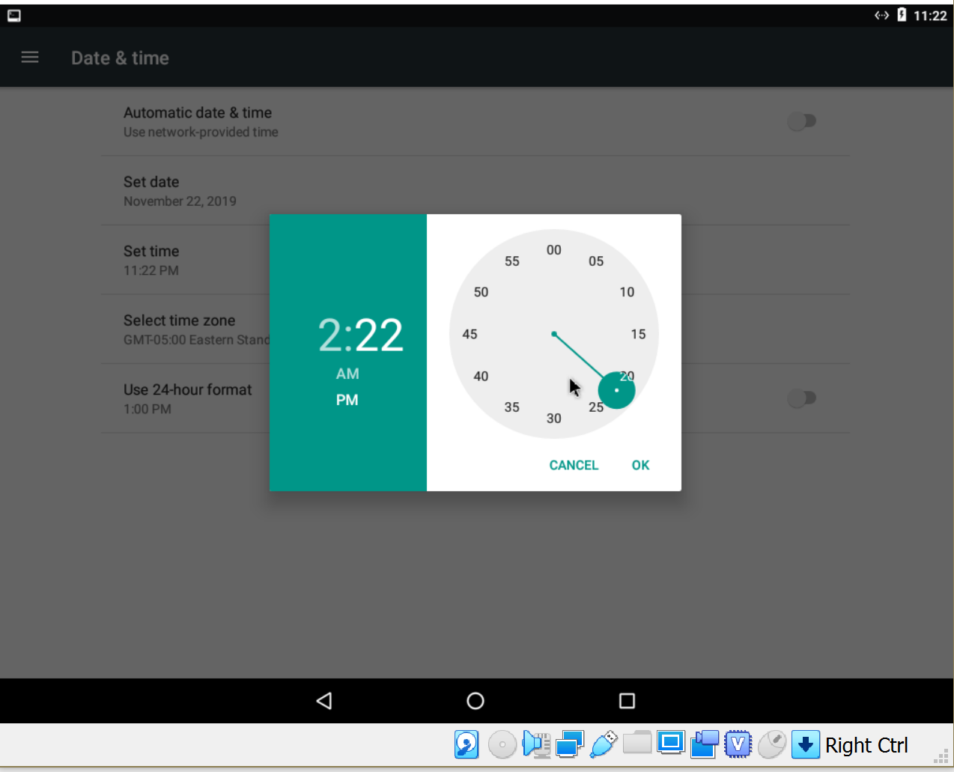

To trigger the code we first start the application and make sure it is present in the background

Then we change the time which BROADCASTS message

This triggers the code and we can now track the user

Step 6: Tracking the victim

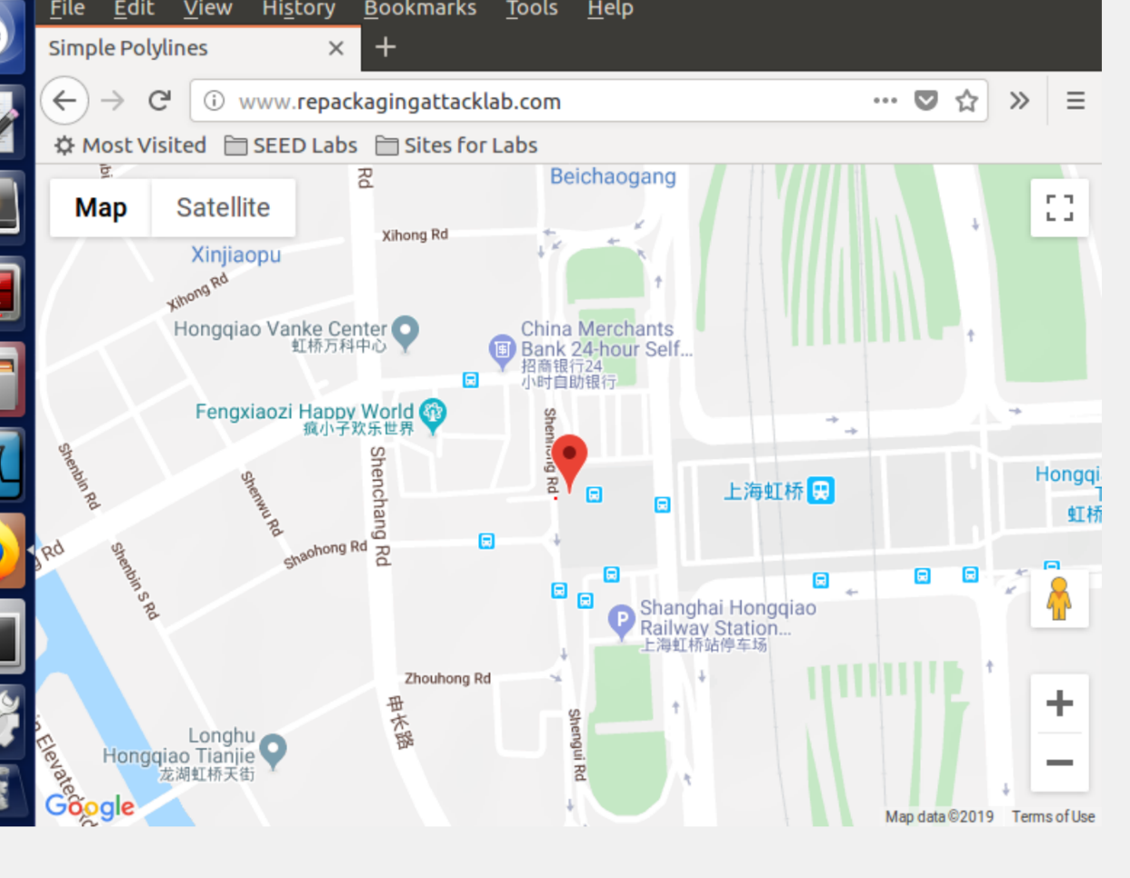

We open our app before setting the time and the malicious code is invoked

to send us the location data. When we click on a location in the mock location app, the app

sets the location of the android VM in that place. The malicious code uses this location and

sends it to the url and looks up the hosts file and send the location to the attack machine.

We open the url on our attack machine and thus we can track the location of the victim